Module-8
231fa04360@gmail.com
LAB -1:
Create a new React Application with the name “myfirstreact”, Run the application to print “welcome to the first session of React” as heading of that page.
Step 1: Create the React Application
npx create-react-app myfirstreact
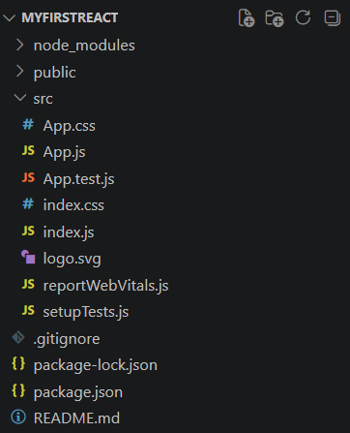
Step 2: App.js:
function App() {
return (
<div>
<h1><center>Welcome to the first session of React</center></h1>
</div>
);
}
export default App;
Step 3: Run the Application
npm start

LAB -2:
Create a react app for Student Management Portal named StudentApp and create a component named Home which will display the Message “Welcome to the Home page of Student Management Portal”. Create another component named About and display the Message “Welcome to the About page of the Student Management Portal”. Create a third component named Contact and display the Message “Welcome to the Contact page of the Student Management Portal”. Call all the three components.
Step 2: Create the React Project
npx create-react-app StudentApp
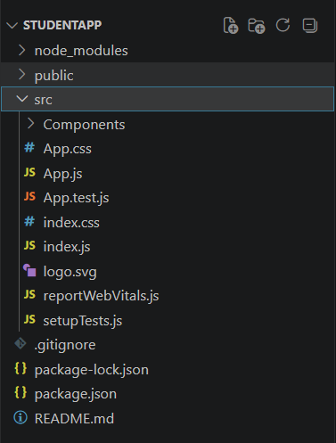
Step 2: Create Components Folder
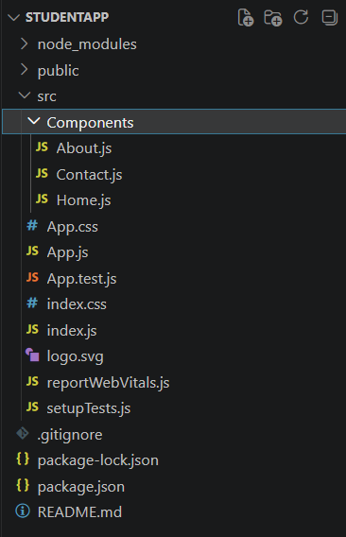
Home.js:
function Home() {
return (
<div>
<center>
<h1>Welcome to Home Page of Student Management Portal</h1>
</center>
</div>
);
}
export default Home;
About.js:
function About() {
return (
<div>
<center>
<h1>Welcome to About Page of Student Management Portal</h1>
</center>
</div>
);
}
export default About;
Contact.js:
function Contact() {
return (
<div>
<center>
<h1>Welcome to Contact Page of Student Management Portal</h1>
</center>
</div>
);
}
export default Contact;
App.js:
import Home from "./Components/Home";
import About from "./Components/About";
import Contact from "./Components/Contact";
function App() {
return (
<div>
<Home />
<About />
<Contact />
</div>
);
}
export default App;

Step 3: Run the application
npm start

LAB -3:
Create a react app for Student Management Portal named scorecalculatorapp and create a function component named “CalculateScore” which will accept Name, School, Total and goal in order to calculate the average score of a student and display the same.
Step 1: Create the React Project
npx create-react-app scorecalculatorapp
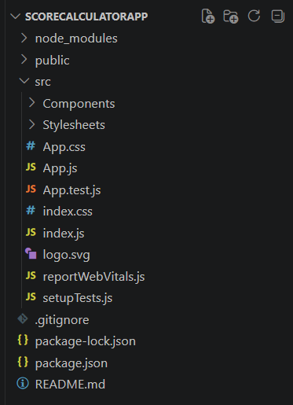
Step 2: Create Components Folder
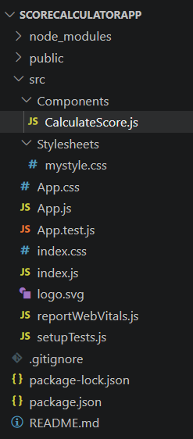

CalculateScore.js:
import "../Stylesheets/mystyle.css";
function CalculateScore(props) {
let score = (props.total / props.goal).toFixed(2);
return (
<div className="student">
<h1>Student Details:</h1>
<h3 className="name">
Name: <span>{props.name}</span>
</h3>
<h3 className="school">
School: <span>{props.school}</span>
</h3>
<h3 className="total">
Total: <span>{props.total} Marks</span>
</h3>
<h3 className="score">
Score:{score}%
</h3>
</div>
);
}
export default CalculateScore;
mystyle.css:
.student{
text-align:center;
margin-top:40px;
}
h1{
color:brown;
font-size:50px;
}
.name{
color:blue;
}
.school{
color:red;
}
.total{
color:brown;
}
.score{
color:green;
}
span{
color:mediumpurple;
font-weight:normal;
}
App.js:
import CalculateScore from "./Components/CalculateScore";
function App() {
return (
<div>
<CalculateScore
name="Steeve"
school="DNV Public School"
total={284}
goal={300}
/>
</div>
);
}
export default App;
Step 3: Run the application
npm start

LAB -4:
Create a new react application using create-react-app tool with the name as “blogapp”
Step 1: Create React Project
npx create-react-app blogapp
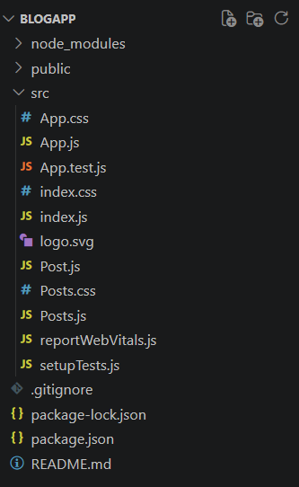
Step 2: Create Post.js
class Post {
constructor(id, title, body) {
this.id = id;
this.title = title;
this.body = body;
}
}
export default Post;
Step 3: Create Posts.js
import React, { Component } from "react";
import Post from "./Post";
import "./Posts.css";
class Posts extends Component {
constructor(props) {
super(props);

this.state = {
posts: []
};
}
loadPosts() {
fetch("https://jsonplaceholder.typicode.com/posts")
.then((response) => response.json())
.then((data) => {
const postList = data.map(
item => new Post(item.id, item.title, item.body)
);
this.setState({
posts: postList
});
})
.catch((error) => {
alert(error);
});
}
componentDidMount() {
this.loadPosts();
}
componentDidCatch(error) {
alert(error);
}
render() {
return (
<div className="container">
<h1 className="heading">Blog Posts</h1>

{this.state.posts.map(post => (
<div className="post" key={post.id}>
<h3>{post.title}</h3>
<p>{post.body}</p>
</div>
))}
</div>
);
}
}
export default Posts;
App.js:
import Posts from "./Posts";
function App() {
return (
<div>
<Posts />
</div>
);
}
export default App;
Step 4: Run the application
npm start

LAB -5:
My Academy team at Cognizant want to create a dashboard containing the details of ongoing and completed cohorts. A react application is created which displays the detail of the cohorts using react component. You are assigned the task of styling these react components.
Step 1: Create a New React App
npx create-react-app cohorttracker
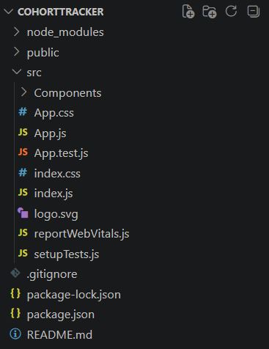
CohortDetails.module.css:
.box{
width:300px;
display:inline-block;
margin:10px;
padding:10px 20px;
border:1px solid black;
border-radius:10px;
vertical-align:top;
}
dt{
font-weight:500;
}
.ongoing{
color:green;
}
.completed{
color:blue;
}
.container{
padding:20px;
}
.title{
margin-left:10px;
}
CohortDetails.js:
import styles from "./CohortDetails.module.css";
function CohortDetails(props) {
return (
<div className={styles.box}>
<h3
className={
props.status === "Ongoing"
? styles.ongoing
: styles.completed
}
>
{props.name}
</h3>
<dl>
<dt>Started On</dt>
<dd>{props.startDate}</dd>
<dt>Current Status</dt>
<dd>{props.status}</dd>
<dt>Coach</dt>
<dd>{props.coach}</dd>
<dt>Trainer</dt>
<dd>{props.trainer}</dd>
</dl>
</div>
);
}
export default CohortDetails;
App.js:
import CohortDetails from "./Components/CohortDetails";
import styles from "./Components/CohortDetails.module.css";
function App() {
return (
<div className={styles.container}>
<h1 className={styles.title}>Cohorts Details</h1>
<CohortDetails
name="INTADMDF10 - .NET FSD"
startDate="22-Feb-2022"
status="Scheduled"
coach="Aathma"
trainer="Jojo Jose"
/>

<CohortDetails
name="ADM21JF014 - Java FSD"
startDate="10-Sep-2021"
status="Ongoing"
coach="Apoorv"
trainer="Elisa Smith"
/>
<CohortDetails
name="CDBJF21025 - Java FSD"
startDate="24-Dec-2021"
status="Ongoing"
coach="Aathma"
trainer="John Doe"
/>
</div>
);
}
export default App;
Run the Application:
npm start

LAB -9:
Create a React Application named “cricketapp” with the following components:
- ListofPlayers
- IndianPlayers

Step 1: Create React Project
npx create-react-app cricketapp
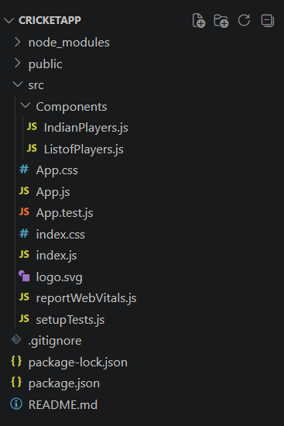

Step 2: Create ListofPlayers.js
function ListofPlayers() {
const players = [
{ name: "Mr. Jack", score: 50 },
{ name: "Mr. Michael", score: 70 },
{ name: "Mr. John", score: 40 },
{ name: "Mr. Ann", score: 61 },
{ name: "Mr. Elisabeth", score: 61 },
{ name: "Mr. Sachin", score: 95 },
{ name: "Mr. Dhoni", score: 100 },
{ name: "Mr. Virat", score: 84 },
{ name: "Mr. Jadeja", score: 64 },
{ name: "Mr. Raina", score: 75 },
{ name: "Mr. Rohit", score: 80 }
];
const lowScorePlayers = players.filter(player => player.score <= 70);
return (
<div>
<h1>List of Players</h1>
<ul>
{
players.map((player, index) => (
<li key={index}>
{player.name} {player.score}
</li>
))
}
</ul>
<hr />
<h1>List of Players having Scores Less than 70</h1>
<ul>
{
lowScorePlayers.map((player, index) => (
<li key={index}>
{player.name} {player.score}
</li>
))
}
</ul>
</div>
);}
export default ListofPlayers;
Step 3: Create IndianPlayers.js
function IndianPlayers() {
const players = [
"Sachin1",
"Dhoni2",
"Virat3",
"Rohit4",
"Yuvaraj5",
"Raina6"
];
const [first, second, third, fourth, fifth, sixth] = players;
const oddPlayers = [first, third, fifth];
const evenPlayers = [second, fourth, sixth];
const T20Players = [
"Mr. First Player",
"Mr. Second Player",
"Mr. Third Player"
];
const RanjiPlayers = [
"Mr. Fourth Player",
"Mr. Fifth Player",
"Mr. Sixth Player"
];
const mergedPlayers = [...T20Players, ...RanjiPlayers];
return (
<div>
<h1>Odd Players</h1>
<ul>
<li>First : {oddPlayers[0]}</li>
<li>Third : {oddPlayers[1]}</li>
<li>Fifth : {oddPlayers[2]}</li>
</ul>
<hr />
<h1>Even Players</h1>
<ul>
<li>Second : {evenPlayers[0]}</li>
<li>Fourth : {evenPlayers[1]}</li>
<li>Sixth : {evenPlayers[2]}</li>
</ul>
<hr />
<h1>List of Indian Players Merged:</h1>
<ul>
{
mergedPlayers.map((player, index) => (
<li key={index}>{player}</li>
))
}
</ul>
</div>
);
}
export default IndianPlayers;
App.js:
import ListofPlayers from "./Components/ListofPlayers";
import IndianPlayers from "./Components/IndianPlayers";
function App() {
const flag = true;
if (flag) {
return <ListofPlayers />;
} else {
return <IndianPlayers />;
}
}
export default App;
Step 4: Run the application
npm start
When Flag=true

When Flag=false

LAB -10:
Create a React Application named “officespacerentalapp” which uses React JSX to create elements, attributes and renders DOM to display the page.
Create an element to display the heading of the page.
Attribute to display the image of the office space
Create an object of office to display the details like Name, Rent and Address.
Create a list of Object and loop through the office space item to display more data.
To apply Css, Display the color of the Rent in Red if it’s below 60000 and in Green if it’s above 60000.
Step 1: Create the React Project
npx create-react-app officespacerentalapp
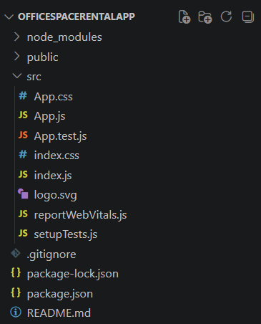
App.js:
import "./App.css";
function App() {
const office = {
Name: "Skyline Office",
Rent: 55000,
Address: "Hyderabad"
};
const offices = [
{
Name: "Skyline Office",
Rent: 55000,
Address: "Hyderabad"
},
{
Name: "Tech Park",
Rent: 75000,
Address: "Bangalore"
},
{
Name: "Business Hub",
Rent: 60000,
Address: "Chennai"
}
];
return (
<div className="container">
<h1>Office Space Rental App</h1>
<img
src="/office.jpg"
alt="Office Space"
className="office-image"
/>
<h2>Single Office Details</h2>
<p><b>Name:</b> {office.Name}</p>
<p>
<b>Rent:</b>
<span
style={{
color: office.Rent < 60000 ? "red" : "green"
}}
>
{" "}₹{office.Rent}
</span>
</p>
<p><b>Address:</b> {office.Address}</p>
<hr />
<h2>Office Space List</h2>
<div className="office-list">
{offices.map((item, index) => (
<div className="card" key={index}>
<h3>{item.Name}</h3>
<p>
<b>Rent:</b>
<span
style={{
color: item.Rent < 60000 ? "red" : "green"
}}
>
{" "}₹{item.Rent}
</span>
</p>
<p>
<b>Address:</b> {item.Address}
</p>
</div>
))}
</div>
</div>
);
}
export default App;
App.css:
.container{
margin:30px;
font-family:Arial;
}
img{
border-radius:10px;
}
.card{
border:1px solid gray;
padding:15px;
margin-top:15px;
width:300px;
border-radius:10px;
}
Step 2: Run the application
npm start

LAB -11:
Create a React Application “eventexamplesapp” to handle various events of the form elements in HTML.
- Create “Increment” button to increase the value of the counter and “Decrement” button to decrease the value of the counter. The “Increase” button should invoke multiple methods.
  - To increment the value
  - Say Hello followed by a static message.

Step 1: Create React Project
npx create-react-app eventexamplesapp
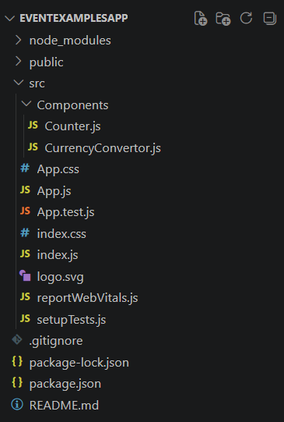
Step 2: Create components folder
Counter.js:
import { useState } from "react";
function Counter() {
const [count, setCount] = useState(0);
function increment() {
setCount(count + 1);
}
function decrement() {
setCount(count - 1);
}
function sayHello() {
alert("Hello! Have a Nice Day.");
}
function incrementAndHello() {
increment();
sayHello();
}
function sayWelcome(message) {
alert(message);
}
function onPress() {
alert("I was clicked");
}
return (
<div>
<h2>Counter : {count}</h2>
<button onClick={incrementAndHello}>
Increment
</button>
&nbsp;
<button onClick={decrement}>
Decrement
</button>
<br /><br />
<button onClick={() => sayWelcome("Welcome")}>
Say Welcome
</button>
<br /><br />
<button onClick={onPress}>
OnPress
</button>
</div>
);
}
export default Counter;
CurrencyConvertor.js:
import { useState } from "react";
function CurrencyConvertor() {
const [rupees, setRupees] = useState("");
const [euro, setEuro] = useState("");
function handleSubmit() {
const converted = (rupees / 90).toFixed(2);
setEuro(converted);
}
return (
<div>
<h2>Currency Convertor</h2>
<input
type="number"
placeholder="Enter Rupees"
value={rupees}
onChange={(e) => setRupees(e.target.value)}
/>
<br /><br />
<button onClick={handleSubmit}>
Convert
</button>
<br /><br />
<h3>Euro : €{euro}</h3>
</div>
);
}
export default CurrencyConvertor;
App.js:
import Counter from "./Components/Counter";
import CurrencyConvertor from "./Components/CurrencyConvertor";
function App() {
return (
<div style={{ margin: "30px" }}>
<h1>Event Examples App</h1>
<Counter />
<hr />
<CurrencyConvertor />
</div>
);
}
export default App;
Step 3: Run the application
npm start

LAB -12:
Create a React Application named “ticketbookingapp” where the guest user can browse the page where the flight details are displayed whereas the logged in user only can book tickets.
The Login and Logout buttons should accordingly display different pages. Once the user is logged in the User page should be displayed. When the user clicks on Logout, the Guest page should be displayed.
Step 1: Create the React Project
npx create-react-app ticketbookingapp
Step 2: Create components folder
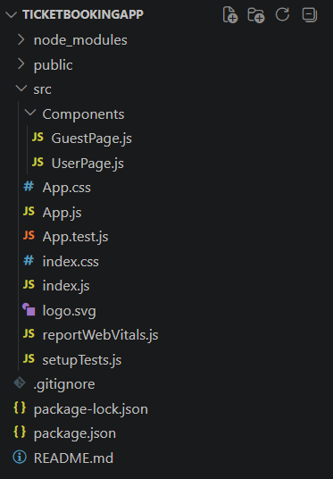
App.js:
import { useState } from "react";
function App() {
const [isLoggedIn, setIsLoggedIn] = useState(false);
return (
<div style={{ marginLeft: "120px", marginTop: "80px" }}>
{isLoggedIn ? (
<div>
<h1>Welcome back</h1>
<button onClick={() => setIsLoggedIn(false)}>
Logout
</button>
</div>
) : (
<div>
<h1>Please sign up.</h1>
<button onClick={() => setIsLoggedIn(true)}>
Login
</button>
</div>
)}
</div>
);
}
export default App;
Step 3: Run the application
npm start

LAB -13:
Create a React App named “bloggerapp” in with 3 components.
- Book Details
- Blog Details
- Course Details
Implement this with as many ways possible of Conditional Rendering.
Step 1: Create React Project
npx create-react-app bloggerapp
Step 2: Create components folder
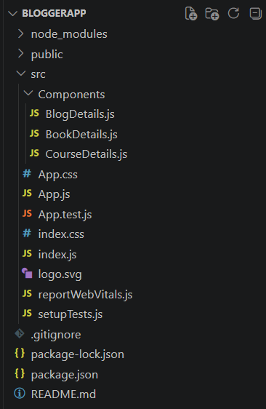
CourseDetails.js:
function CourseDetails() {
const courses = [
{
name: "Angular",
date: "4/5/2021"
},
{
name: "React",
date: "6/3/2021"
}
];
return (
<div>
<h1>Course Details</h1>
{
courses.map((course,index)=>(
<div key={index}>
<h2>{course.name}</h2>
<h4>{course.date}</h4>
</div>
))
}
</div>
);
}
export default CourseDetails;
BookDetails.js:
function BookDetails() {
const books = [
{
name:"Master React",
price:670
},
{
name:"Deep Dive into Angular 11",
price:800
},
{
name:"Mongo Essentials",
price:450
}
];
return(
<div>
<h1>Book Details</h1>
{
books.map((book,index)=>(
<div key={index}>
<h3>{book.name}</h3>
<h4>{book.price}</h4>
</div>
))
}
</div>
);
}
export default BookDetails;
BlogDetails.js:
function BlogDetails(){
const blogs=[
{
title:"React Learning",
author:"Stephen Biz",
description:"Welcome to learning React!"
},
{
title:"Installation",
author:"Schewzdenier",
description:"You can install React from npm."
}
];
return(
<div>
<h1>Blog Details</h1>
{
blogs.map((blog,index)=>(
<div key={index}>
<h2>{blog.title}</h2>
<h4>{blog.author}</h4>
<p>{blog.description}</p>
</div>
))
}
</div>
);
}
export default BlogDetails;
App.js:
import "./App.css";
import BookDetails from "./Components/BookDetails";
import BlogDetails from "./Components/BlogDetails";
import CourseDetails from "./Components/CourseDetails";
function App() {
const showCourses = true;
const showBooks = true;
const showBlogs = true;
return (
<div className="container">
{showCourses && <CourseDetails />}
{showBooks ? <BookDetails /> : null}
{showBlogs ? <BlogDetails /> : null}
</div>
);
}
export default App;
Step 3: Run the application
npm start

